Between 2013 and 2014, the City of Shakopee saw its narcotics arrest increase by 65 percent. The following year, arrests grew another 30 percent. It became evident to Shakopee Police Department leaders that narcotic use is not a problem officers can simply arrest their way out of.
This revelation was the catalyst behind a new program aimed at supporting narcotic and other drug users before they become arrest statistics. Launched in April 2016, the Recovery Assistance Program (RAP) provides financial assistance to people seeking drug/alcohol treatment while building a relationship between officers and these high-risk community members. The program strives to provide scholarship recipients with an additional support network needed to succeed.
The Recovery Assistance Program was launched with two major goals: first, to provide financial assistance to people seeking drug/alcohol treatment via a $3,000 scholarship toward the cost of treatment; second, to build a relationship and additional support network for RAP participants.
To become a participant in the Recovery Assistance Program an individual must be a Shakopee resident seeking treatment at one of three RAP partner treatment centers. Participants who meet these criteria, fill out a scholarship application (figure 1.1), usually with the assistance of the treatment provider. The scholarship application includes basic application information, drug of choice and statement of need. Participants must also agree to complete a 30-day check-in form. After an application is received, the applicant is screened against the Shakopee in-house records. As can be expected, many applicants have had previous contact with the Shakopee Police Department. This screening is not for the purpose of disqualifying applicants. Rather it provides an opportunity for program administrators to speak with officers who may have had previous contact with the applicant to ensure the officers feel comfortable with the decision to accept the applicant. Once the applicant is admitted into the program, he or she must complete at least 30 days of treatment before becoming eligible for the scholarship. After the initial 30 days are completed, the treatment center sends the police department the participant’s bill (minus insurance contributions) and the police department pays up to $3,000 of the bill. The funds used for the scholarships are from asset forfeiture funds; no tax dollars are used toward the program.
The Shakopee Police Department understands that the financial burden is often one of the biggest hurdles when seeking drug/alcohol treatment. We also know it is not the only obstacle. For the program to succeed, it is imperative participants know that the Police Department is available to help them with their recovery goals. Once the applicant is accepted into the program, he or she receives a generic acceptance letter, as well as a custom welcome note from the Chief of Police. This custom note is crucial to setting the tone that we are a partner in his/her recovery process. The applicant is also matched with a member of the police department to serve as a pen-pal. Department pen-pals write notes encouraging participants on their recovery journey. Local businesses have donated meal vouchers so pen-pals can take their pal out to lunch. The pen-pal program serves not only to support the participant in his/her recovery, but it also shows the participant there is a real person behind that badge who genuinely cares about them and their sobriety. In fact, one participant was having difficulties getting a job due to his convicted felon status, so the pen-pal wrote a reference letter which resulted in the participant getting hired. As an unintended benefit, the Shakopee Police Department also found that the pen-pal program helped boost morale among the department participants. Usually when an officer is dealing with a narcotics user, it is an unpleasant experience, but the pen-pal program illustrates to officers the good they are doing for the community. Participants in the program are asked to fill out a 30-day check in form (figure 1.2) to allow the police department to continuously improve the program and to help department pen-pals stay connected with the participant.
- Level of Innovation
Shakopee’s Recovery Assistance Program is the first of its kind. While there are other recovery assistance type programs out there, the Shakopee Police Department’s program is unique in several ways. First, RAP is not an amnesty program. Many other programs simply provide amnesty and then pass the individual along to a treatment provider. Shakopee’s RAP program is unique in that it forms a partnership with those seeking help, which in some cases goes well-beyond treatment. Second, many programs have a primary focus on heroin. While heroin is definitely a concern, RAP is available to anyone seeking treatment, regardless of his/her type of use. RAP participants include a variety of users, including alcohol, marijuana and opioid users. Third, RAP is the only program we know of in the country that addresses the financial burden of treatment.
Shakopee Police Department was also the first department in Minnesota to join PAARI (Police Assisted Addiction and Recovery Initiative) which allows for increased networking opportunities among other departments that have recovery assistance programs. While Shakopee Police Department is a member of PAARI, RAP varies drastically from other PAARI-supported programs, as explained above.
- Effectiveness
The Shakopee Police Department has been tracking the following to measure the program’s impact:
Participant | Drug of Choice | Shakopee Drug/Alcohol Contacts Before Participation | Shakopee Drug/Alcohol Contacts After Participation | Completed at Least 30 Days of Treatment
001 | Alcohol | 0 | 0 | Yes
002 | Alcohol | 1 | 0 | Yes
003 | Prescription pills | 3 | 1* | Yes
004 | Methamphetamines | 7 | 0 | Yes
005 | Marijuana | 3 | 0 | Yes
006 | Alcohol | 0 | 0 | Yes
007 | Marijuana, Prescription pills | 5 | 1 | Yes
008 | Alcohol | 4 | 0 | Yes
009 | Unknown | 4 | 0 | Yes
010 | Alcohol | 1 | 0 | In progress
*Participant in RAP was not in possession of drugs or alcohol
Two of the main points of consideration are the reduction in police contacts related to drug or alcohol use in all of the participants, as well as the fact that all of the participants (with the exception of the one in progress) completed at least 30 days of treatment. After speaking with those who work in treatment facilities, many of them listed the financial burden as one of the main reasons participants do not continue their treatment program. RAP removes the financial burden, and therefore, participants can focus their energy on receiving the treatment needed.
In addition to these statistics, statements made by the participants, and other community partners, are an important gauge of the effectiveness of the program:
“…the scholarship program was a lifesaver and it helped me focus more on recovery than the terrifying cost of it all.” – Participant
“Again, I appreciate you reaching out to me and showing you care about what I am doing with my life even after being labelled a felon.” – Participant
“I like that they are trying to help people that are using before locking them up and things get worse.” – Participant
“One of the biggest problems our clients have is financial stressors, taking away that financial burden early on is absolutely huge.” – Treatment Center Managing Director
“Shakopee is the first in Minnesota, but it shouldn’t be the last. Even beyond the value of treatment itself, this program may offer a unique way for police to change the way they are perceived in their communities. It may also help move us toward a model that seeks to help addicts with their disease rather than punish them.” – Star Tribune Editorial Board
- Ability to Replicate
This program is one that can easily be replicated in any size department. The financial side will always be a struggle; however, departments can offer a scholarship of a lower amount if financing is an issue. Even a scholarship of a few hundred dollars can assist those burdened by the cost of an assessment. If a scholarship is not feasible, departments can assist in other ways, such as providing transportation or gas gift cards or partnering with local daycares to provide child care services. The staff commitment is minimal. The recruitment of participants is mainly taken care of by the treatment centers. Shakopee Police Department staff takes care of reviewing the applications, setting up the pen-pal program and dispersing the funds. As an estimate, the program takes approximately one hour per week of work.
RAP is independent of a drug court program. RAP allows people who may be seeking treatment but not been arrested to participate, a population that does not reap the benefits of a drug court program. RAP also goes beyond a drug court by offering financial assistance and a deep relationship with local police officers.
- Overall Impact
  - Distributed $14,899.38 in scholarships since April 2016
(After insurance, many participants did not need the entire $3,000 available.)
  - Recognized in the Star Tribune and the Star Tribune editorials
  - Recognized in USA Today
  - Recognized by the Shakopee Valley News as well as several other local television news organizations
  - Highlighted by Senator Amy Klobuchar and Office of National Drug Control Policy Director Michael Botticell and was the only program featured tor receive a full round of applause
  - Multiple public speaking requests to discuss program
  - Article written for the MN Chiefs of Police magazine
Shakopee Police Department’s Recovery Assistance Program is an innovative, first-of-its kind, program. It achieves the 21st Century Policing pillar of “Community Policing and Crime Reduction.” RAP is easily replicable and provides an alternative to “arresting your way out of the problem” which is undeniably not working in the case of drug and alcohol addiction. RAP is positively perceived throughout the recovery community. RAP is one of the most positive programs the Shakopee Police Department has had among the media and the community.

Figure 1.1
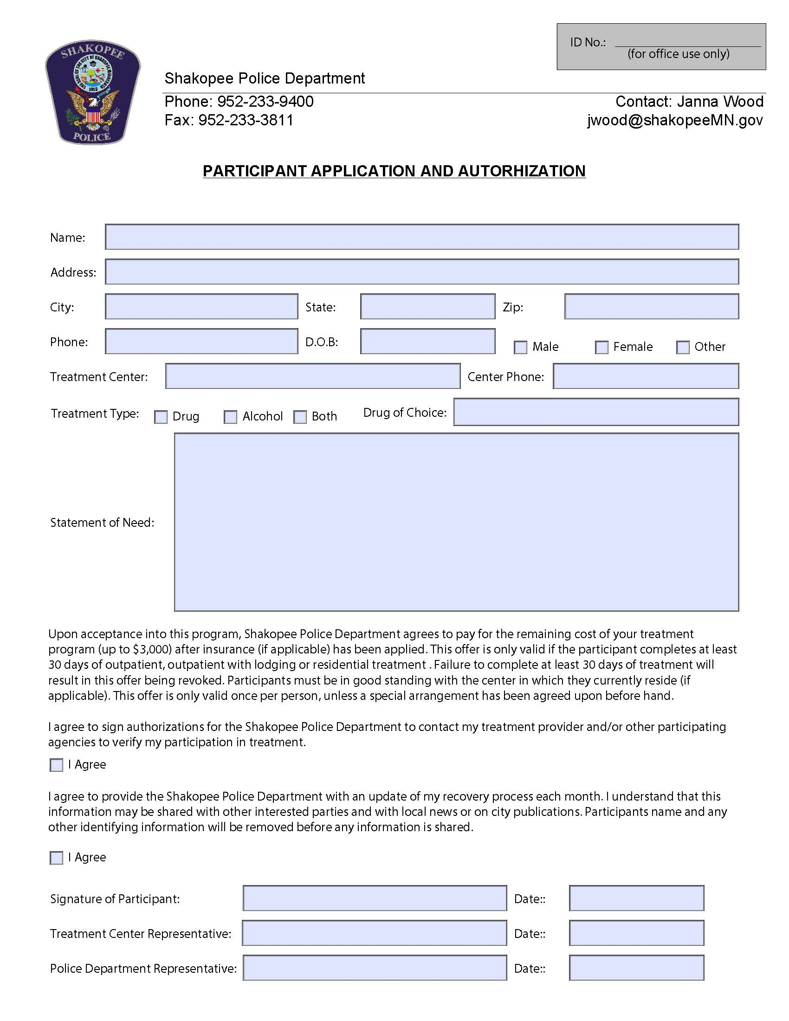
Figure 1.2
